Selenium Webdriver

Version 1.1.0



 | Prepared By | Reviewed by | Approved By
Name | Vijayakarthikeyan | [Supervisor] | [Project manager]
Role
Signature
Date

Table Of Contents
1.0 Difference between Webdriver & RC 3
2.0 Architecture of Webdriver 3
3.0 First Selenium Webdriver script 4
4.0 Locating GUI Elements 6
4.1.1 Note on Using findElement(By.cssSelector()) 8
5.0 Common Commands 9
5.1.1 Instantiating Web Elements 9
5.1.2 Clicking on an Element 9
5.1.3 Get Commands 10
5.1.4 Navigate commands 11
5.1.5 Closing and Quitting Browser Windows 12
6.0 Switching Between Frames 14
7.0 Switching Between Pop-up Windows 15
8.0 Alert 17
9.0 Wait 17
9.1.1 Implicit Wait 17
9.1.2 Explicit Wait 18
10.0 Conditions 20
10.1 Using ExpectedConditions 20
10.1 Catching Exceptions 21
11.0 Summary so far 22
12.0 Accessing Forms in WebDriver 23
12.1 Accessing Form Elements [ Input Box] 23
12.1.1 Entering Values in Input Boxes 23
12.1.2 Deleting Values in Input Boxes 24
12.1.3 Radio Button 24
12.1.4 Check Box 24
12.1.5 Links 25
12.1.6 Drop-Down Box 26
12.1.7 Selecting Items in a Multiple SELECT element 27
12.1.8 Submitting a Form & Summary of operating a Form 28
13.0 Accessing Image Links 29
14.0 Xpath 31
14.1.1 XPath Syntax 31
14.2 Accessing Nested Tables 34
14.3 Finding xpath through FireBug 36
15.0 PageFactory 39
16.0 Handling Cookies 39
17.0 Setting Browser options [DesiredCapabilities] 40
18.0 Specifying Browser proxy 41
19.0 Important scripts & informations 41
19.1 TO find number of Frames in a web link 41
19.2 Important infos 42
19.3 SELENESE TABLE FORMAT 48
19.4 Mouse over Functions 49
20.0 Important coding informations 52
20.1 For loop type 52
21.0 TestNG 53
21.1 Annotation 53
21.1.1 @TestAnnotation-Attributes 53
21.1.2 TestNG-Grouping 54
21.2 Data Provider 54
21.3 ExpectedExceptions 55
21.4 Test Suite 55
21.4.1 Run Test Suite 56
21.5 TestNG Report 56
21.6 Difference between Junit & TestNG 57
21.7 Parametric Testing 57
21.8 TestNG Summary 57
22.0 Change Log 58

Difference between Webdriver & RC
Selenium-RC which uses JS injection to interact with browsers, WebDriver uses browsers native interaction.
Web Driver uses Object Oriented libraries/approach to create the automation suite.
Automation Execution Speed would considerably increases when compared to Selenium-RC (except Internet Explorer Browser) because of native interaction.
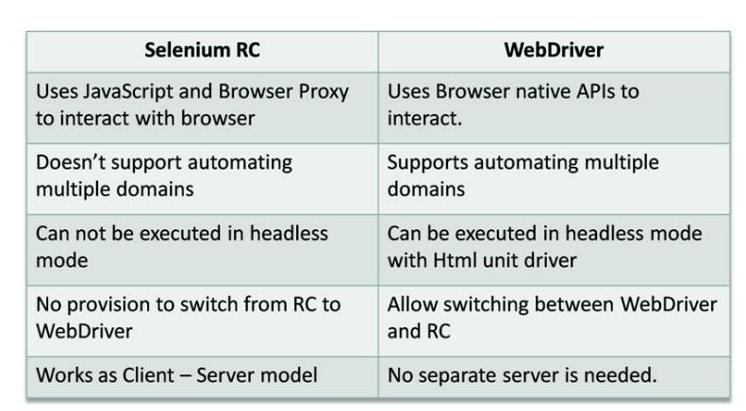

Architecture of Webdriver
Web Driver uses native calls to perform browser actions.
For Internet Explorer it uses COM object and for Firefox it uses XPCOM objects.
With the help of ChromeDriver.exe provided by Google, WebDriver interacts with the Chrome browser.
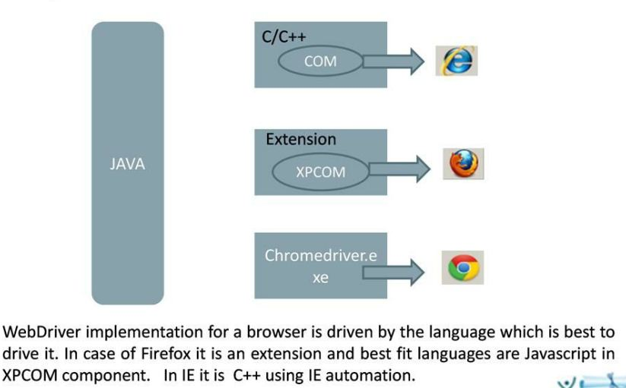

First Selenium Webdriver script
Using the Java class “myclass” that we created in the previous tutorial, let us try to create a WebDriver script that would:

- fetch Mercury Tours’ homepage
- verify its title
- print out the result of the comparison
- close it before ending the entire program.

WebDriver Code
Below is the actual WebDriver code for the logic presented by the scenario above

package mypackage;

import org.openqa.selenium.WebDriver;

import org.openqa.selenium.firefox.FirefoxDriver;

public class myclass {

public static void main(String[] args) {

// declaration and instantiation of objects/variables

WebDriver driver = new FirefoxDriver();

String baseUrl = "http://newtours.demoaut.com";

String expectedTitle = "Welcome: Mercury Tours";

String actualTitle = "";

// launch Firefox and direct it to the Base URL

driver.get(baseUrl);

// get the actual value of the title

actualTitle = driver.getTitle();

/*

* compare the actual title of the page witht the expected one and print

* the result as "Passed" or "Failed"

*/

if (actualTitle.contentEquals(expectedTitle)){

System.out.println("Test Passed!");

} else {

System.out.println("Test Failed");

}

//close Firefox

driver.close();

// exit the program explicitly

System.exit(0);

}

}

Locating GUI Elements
Locating elements in WebDriver is done by using the “findElement(By.locator())” method. The “locator” part of the code is same as any of the locators previously discussed in the Selenium IDE chapters of these tutoriasl.Infact , it is recommeded you locate GUI elements using IDE and once successfully identified export the code to webdriver.
Here is a sample code that locates an element by its id. Facebook is used as the Base URL

package mypackage;

import org.openqa.selenium.By;

import org.openqa.selenium.WebDriver;

import org.openqa.selenium.firefox.FirefoxDriver;

public class myclass {

public static void main(String[] args) {

WebDriver driver = new FirefoxDriver();

String baseUrl = "http://www.facebook.com";

String tagName = "";

driver.get(baseUrl);

tagName = driver.findElement(By.id("email")).getTagName();

System.out.println(tagName);

driver.close();

System.exit(0);

}

}

We used the getTagName() method to extract the tag name of that particular element whose id is “email”. When run, this code should be able to correctly identify the tag name “input” and will print it out on Eclipse’s Console window

By.className
finds elements based on the value of the “class” attribute
findElement(By.className(“someClassName”))
By.cssSelector
finds elements based on the driver’s underlying CSS Selector engine
findElement(By.cssSelector(“input#email”))
By.id
locates elements by the value of their “id” attribute
findElement(By.id(“someId”))

By.linkText
finds a link element by the exact text it displays
findElement(By.linkText(“REGISTRATION”))

By.name
locates elements by the value of the “name” attribute
findElement(By.name(“someName”))

By.partialLinkText
locates elements that contain the given link text
findElement(By.partialLinkText(“REG”))

By.tagName
locates elements by their tag name
findElement(By.tagName(“div”))

By.xpath
locates elements via XPath
findElement(By.xpath(“//html/body/div/table/tbody/tr/td[2]/table/tbody/tr[4]/td/table/tbody/tr/td[2]/table/tbody/tr[2]/td[3]/form/table/tbody/tr[5]”))

Note on Using findElement(By.cssSelector())
By.cssSelector() does not support the “contains” feature. Consider the Selenium IDE code below -
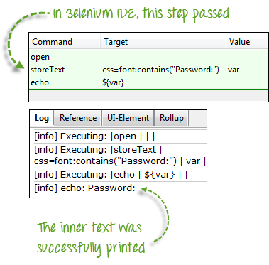

In Selenium IDE above, the entire test passed. However in the WebDriver script below, the same test generated an error because WebDriver does not support the “contains” keyword when used in the By.cssSelector() method.
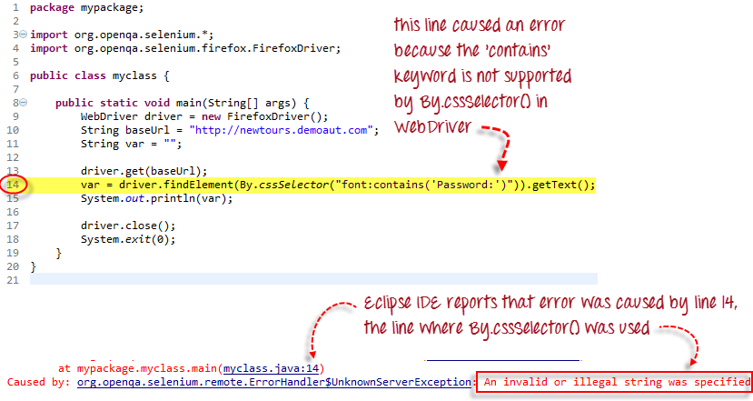

Common Commands

Instantiating Web Elements
Instead of using the long “driver.findElement(By.locator())” syntax every time you will access a particular element, we can instantiate a WebElement object for it. The WebElement class is contained in the “org.openqa.selenium.*” package.
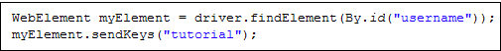

Clicking on an Element
Clicking is perhaps the most common way of interacting with web elements. The click() method is used to simulate the clicking of any element. The following example shows how click() was used to click on Mercury Tours’ “Sign-In” button.
Following things must be noted when using the click() method.
- It does not take any parameter/argument.
- The method automatically waits for a new page to load if applicable.
- The element to be clicked-on, must be visible (height and width must not be equal to zero).

Get Commands
Get commands fetch various important information about the page/element. Here are some important “get” commands you must be familiar with.
get()  Sample usage: | - It automatically opens a new browser window and fetches the page that you specify inside its parentheses.  - It is the counterpart of Selenium IDE’s “open” command.  - The parameter must be a String object.
getTitle()  Sample usage: | - Needs no parameters  - Fetches the title of the current page  - Leading and trailing white spaces are trimmed  - Returns a null string if the page has no title
getPageSource()  Sample usage: | - Needs no parameters  - Returns the source code of the page as a String value
getCurrentUrl()  Sample usage: | - Needs no parameters  - Fetches the string representing the current URL that the browser is looking at
getText()  Sample usage: | - Fetches the inner text of the element that you specify

Navigate commands
These commands allow you to refresh,go-into and switch back and forth between different web pages.
navigate().to()  Sample usage: | - It automatically opens a new browser window and fetches the page that you specify inside its parentheses.  - It does exactly the same thing as the get() method.
navigate().refresh()  Sample usage: | - Needs no parameters.  - It refreshes the current page.
navigate().back()  Sample usage: | - Needs no parameters  - Takes you back by one page on the browser’s history.
navigate().forward()  Sample usage: | - Needs no parameters  - Takes you forward by one page on the browser’s history.

Closing and Quitting Browser Windows
close()  Sample usage: | - Needs no parameters  - It closes only the browser window that WebDriver is currently controlling.
quit()  Sample usage: | - Needs no parameters  - It closes all windows that WebDriver has opened.

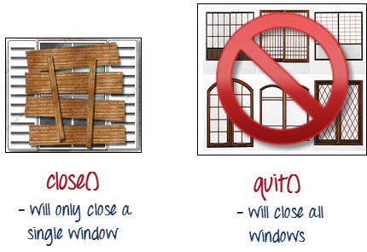
To clearly illustrate the difference between close() and quit(), try to execute the code below. It uses a webpage that automatically pops up a window upon page load and opens up another after exiting.
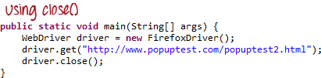
Notice that only the parent browser window was closed and not the two pop-up windows.
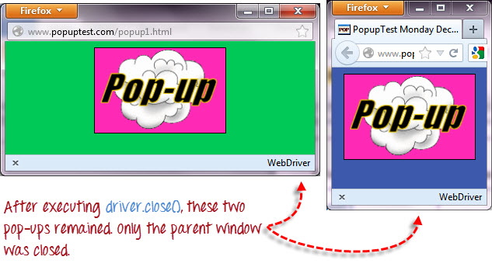
But if you use quit(), all windows will be closed – not just the parent one. Try running the code below and you will notice that the two pop-ups above will automatically be closed as well.

CODE :
package mypackage;

import org.openqa.selenium.WebDriver;

import org.openqa.selenium.firefox.FirefoxDriver;

public class myclass {

public static void main(String[] args) {

WebDriver driver = new FirefoxDriver();

driver.get("http://www.popuptest.com/popuptest2.html");

driver.quit(); // using QUIT all windows will close

}

}

Switching Between Frames
To access GUI elements in a Frame, we should first direct WebDriver to focus on the frame or pop-up window first before we can access elements within them. Let us take, for example, the web page http://selenium.googlecode.com/svn/trunk/docs/api/java/index.html
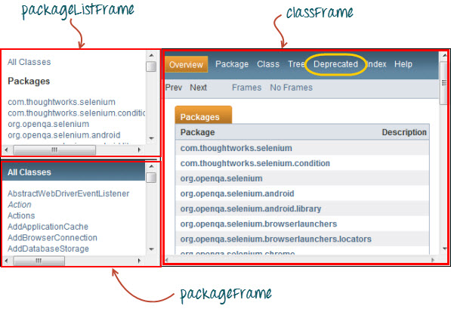
This page has 3 frames whose “name” attributes are indicated above. We wish to access the “Deprecated” link encircled above in yellow. In order to do that, we must first instruct WebDriver to switch to the “classFrame” frame using the “switchTo().frame()” method. We will use the name attribute of the frame as the parameter for the “frame()” part.
view source

print?

CODE:
package mypackage;

import org.openqa.selenium.By;

import org.openqa.selenium.WebDriver;

import org.openqa.selenium.firefox.FirefoxDriver;

public class myclass {

public static void main(String[] args) {

WebDriver driver = new FirefoxDriver();

driver.get("http://selenium.googlecode.com/svn/trunk/docs/api/java/index.html");

driver.switchTo().frame("classFrame");

driver.findElement(By.linkText("Deprecated")).click();

driver.quit();

}

}

After executing this code, you will see that the “classFrame” frame is taken to the “Deprecated API” page, meaning that our code was successfully able to access the “Deprecated” link
Use driver.switchTo().defaultContent() – to move to the parent frame

Switching Between Pop-up Windows
WebDriver allows pop-up windows like alerts to be displayed, unlike in Selenium IDE. To access the elements within the alert (such as the message it contains), we must use the “switchTo().alert()” method. In the code below, we will use this method to access the alert box and then retrieve its message using the “getText()” method, and then automatically close the alert box using the “switchTo().alert().accept()” method.
First, head over to http://jsbin.com/usidix/1 and manually click the “Go!” button there and see for yourself the message text.
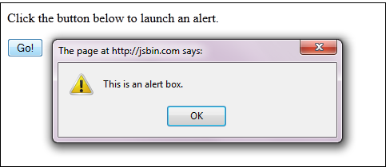
Lets see the WebDriver code to do this-
CODE :
package mypackage;

import org.openqa.selenium.By;

import org.openqa.selenium.WebDriver;

import org.openqa.selenium.firefox.FirefoxDriver;

public class myclass {

public static void main(String[] args) {

WebDriver driver = new FirefoxDriver();

String alertMessage = "";

driver.get("http://jsbin.com/usidix/1");

driver.findElement(By.cssSelector("input[value=\"Go!\"]")).click();

alertMessage = driver.switchTo().alert().getText();

driver.switchTo().alert().accept();

System.out.println(alertMessage);

driver.quit();

}

}

On the Eclipse console, notice that the printed alert message is:
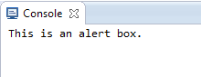

Alert
Alert class provides various methods such as:
accept()
dismiss()
getText()
sendKeys()
such as …
Alert alert = driver.switchTo().alert();
alert.getText();
Alert.accept();

Wait
There are two kinds of waits.
- Implicit wait – used to set the default waiting time throughout the program
- Explicit wait – used to set the waiting time for a particular instance only

Implicit Wait
- It is simpler to code than Explicit Waits.
- It is usually declared in the instantiation part of the code.
- You will only need one additional package to import.
To start using an implicit wait, you would have to import this package into your code.
Then on the instantiation part of your code, add this.
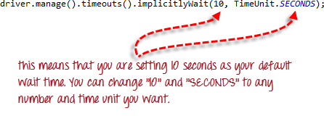

Explicit Wait
Explicit waits are done using the WebDriverWait and ExpectedCondition classes. For the following example, we shall wait up to 10 seconds for an element whose id is “username” to become visible before proceeding to the next command. Here are the steps.
Step 1
Import these two packages:

Step 2
Declare a WebDriverWait variable. In this example, we will use “myWaitVar” as the name of the variable.
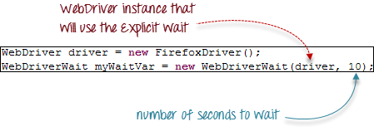
Step 3
Use myWaitVar with ExpectedConditions on portions where you need the explicit wait to occur. In this case, we will use explicit wait on the “username” (Mercury Tours HomePage) input before we type the text “tutorial” onto it.

Conditions
Following methods are used in conditional and looping operations --
- isEnabled() is used when you want to verify whether a certain element is enabled or not before executing a command.
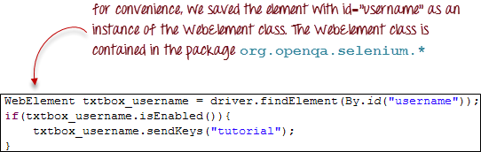
- isDisplayed() is used when you want to verify whether a certain element is displayed or not before executing a command.
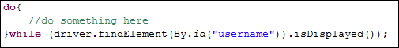
- isSelected() is used when you want to verify whether a certain check box, radio button, or option in a drop-down box is selected. It does not work on other elements.
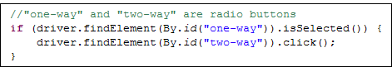

Using ExpectedConditions
The ExpectedConditions class offers a wider set of conditions that you can use in conjunction with WebDriverWait’s until() method.
Below are some of the most common ExpectedConditions methods.
- alertIsPresent() – waits until an alert box is displayed.
- elementToBeClickable() – waits until an element is visible and, at the same time, enabled. The sample code below will wait until the element with id=”username” to become visible and enabled first before assigning that element as a WebElement variable named “txtUserName”.
- frameToBeAvailableAndSwitchToIt() – waits until the given frame is already available, and then automatically switches to it.
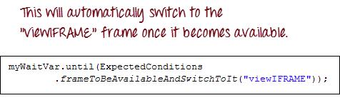

Catching Exceptions
When using isEnabled(), isDisplayed(), and isSelected(), WebDriver assumes that the element already exists on the page. Otherwise, it will throw a NoSuchElementException. To avoid this, we should use a try-catch block so that the program will not be interrupted.
WebElement txtbox_username = driver.findElement(By.id("username"));

try{

if(txtbox_username.isEnabled()){

txtbox_username.sendKeys("tutorial");

}

}

catch(NoSuchElementException nsee){

System.out.println(nsee.toString());

}

If you use explicit waits, the type of exception that you should catch is the “TimeoutException”.
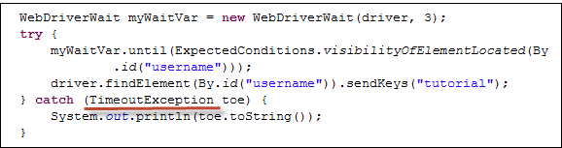

Summary so far
• To start using the WebDriver API, you must import at least these two packages.
• org.openqa.selenium.*
• org.openqa.selenium.firefox.FirefoxDriver
• The get() method is the equivalent of Selenium IDE’s “open” command.
• Locating elements in WebDriver is done by using the findElement(By()) method.
• The following are the available options for locating elements in WebDriver:
• By.className
• By.cssSelector
• By.id
• By.linkText
• By.name
• By.partialLinkText
• By.tagName
• By.xpath
• TheBy.cssSelector() does not support the “contains” feature.
• You can instantiate an element using the WebElement class.
• Clicking on an element is done by using the click() method.
• WebDriver provides these useful get commands:
• get()
• getTitle()
• getPageSource()
• getCurrentUrl()
• getText()
• WebDriver provides these useful navigation commands
• navigate().forward()
• navigate().back()
• navigate().to()
• navigate().refresh()
• The close() and quit() methods are used to close browser windows. Close() is used to close a single window; while quit() is used to close all windows associated to the parent window that the WebDriver object was controlling.
• The switchTo().frame() and switchTo().alert() methods are used to direct WebDriver’s focus onto a frame or alert, respectively.
• Implicit waits are used to set the waiting time throughout the program, while explicit waits are used only on specific portions.
• You can use the isEnabled(), isDisplayed(),isSelected(), and a combination of WebDriverWait and ExpectedConditions methods when verifying the state of an element. However, they do not verify if the element exists.
• When isEnabled(), isDisplayed(),or isSelected() was called while the element was not existing, WebDriver will throw a NoSuchElementException.
• When WebDriverWait and ExpectedConditions methods were called while the element was not existing, WebDriver would throw a TimeoutException

Accessing Forms in WebDriver

Accessing Form Elements [ Input Box]
Input Box
Input boxes refer to either of these two types:
- Text Fields– text boxes that accept typed values and show them as they are.
- Password Fields– text boxes that accept typed values but mask them as a series of special characters (commonly dots and asterisks) to avoid sensitive values to be displayed.
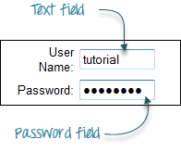

Entering Values in Input Boxes
The sendKeys() method is used to enter values into input boxes.
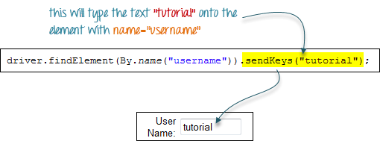

Deleting Values in Input Boxes
The clear() method is used to delete the text in an input box. This method does not need any parameter. The code snippet below will clear out the text “tutorial” in the User Name text box.

Radio Button
Toggling a radio button on is done using the click() method.
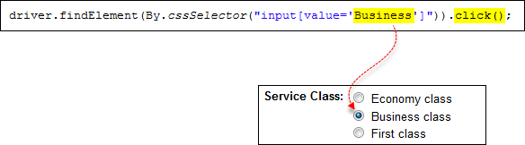

Check Box
Toggling a check box on/off is also done using the click () method.
The code below will click on Facebooks “Keep me logged in” check box twice and then output the result as TRUE when it is toggled on, and FALSE if it is toggled off.
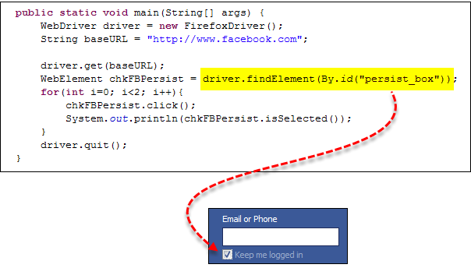
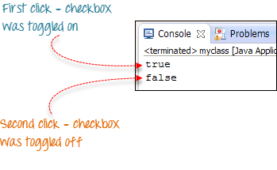

Links
Links also are accessed by using the click() method.
Consider the below link found in Mercury Tours’ homepage.
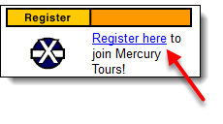
You can access this link using linkText() or partialLinkText() together with click(). Either of the two lines below will be able to access the “Register here” link shown above.

Drop-Down Box
Before we can control drop-down boxes, we must do following two things :
- Import the package org.openqa.selenium.support.ui.Select
- Instantiate the drop-down box as a “Select” object in WebDriver
As an example, go to Mercury Tours’ Registration page (http://newtours.demoaut.com/mercuryregister.php) and notice the “Country” drop-down box there.
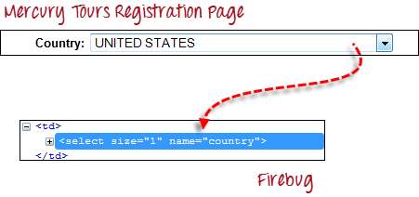
Step 1
Import the “Select” package.
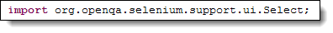
Step 2
Declare the drop-down element as an instance of the Select class. In the example below, we named this instance as “drpCountry”.
Step 3
We can now start controlling “drpCountry” by using any of the available Select methods. The sample code below will select the option “ANTARCTICA”.
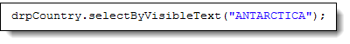

Selecting Items in a Multiple SELECT element
We can also use the selectByVisibleText() method in selecting multiple options in a multi SELECT element. As an example, we will take http://jsbin.com/osebed/2 as the base URL. It contains a drop-down box that allows multiple selections at a time.
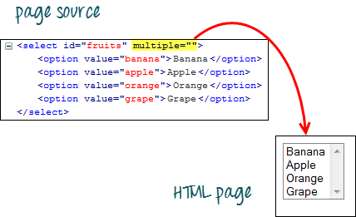
The code below will select the first two options using the selectByVisibleText() method.
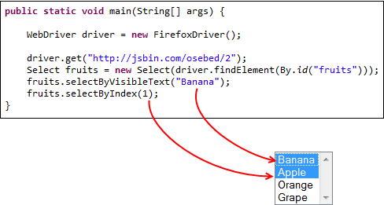

Submitting a Form & Summary of operating a Form
The submit() method is used to submit a form. This is an alternative to clicking the form’s submit button.
You can use submit() on any element within the form, not just on the submit button itself.
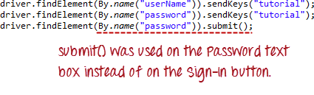
When submit() is used, WebDriver will look up the DOM to know which form the element belongs to, and then trigger its submit function.
- The table below summarizes the commands to access each type of element discussed above.
Element | Command | Description
Input Box | sendKeys() | used to enter values onto text boxes
Input Box | clear() | used to clear text boxes of its current value
Check Box,  Radio Button, | click() | used to toggle the element on/off
Links | click() | used to click on the link and wait for page load to complete before proceeding to the next command.
Drop-Down Box | selectByVisibleText()/  deselectByVisibleText() | selects/deselects an option by its displayed text
Drop-Down Box | selectByValue()/  deselectByValue() | selects/deselects an option by the value of its “value” attribute
Drop-Down Box | selectByIndex()/  deselectByIndex() | selects/deselects an option by its index
Drop-Down Box | isMultiple() | returns TRUE if the drop-down element allows multiple selection at a time; FALSE if otherwise
Drop-Down Box | deselectAll() | deselects all previously selected options
Submit Button | submit()
- WebDriver allows selection of more than one option in a multiple SELECT element.
- To control drop-down boxes, you must first import the org.openqa.selenium.support.ui.Select package and then create a Select instance.
- You can use the submit() method on any element within the form. WebDriver will automatically trigger the submit function of the form where that element belongs to

Accessing Image Links
Image links are images that act as references to other sites or sections within the same page. Since they are images, we cannot use the By.linkText() and By.partialLinkText() methods because image links basically have no link texts at all. In this case, we should resort to using either By.cssSelector or By.xpath. The first method is more preferred because of its simplicity.
In the example below, we will access the “Facebook” logo on the upper left portion of Facebook’s Password Recovery page.
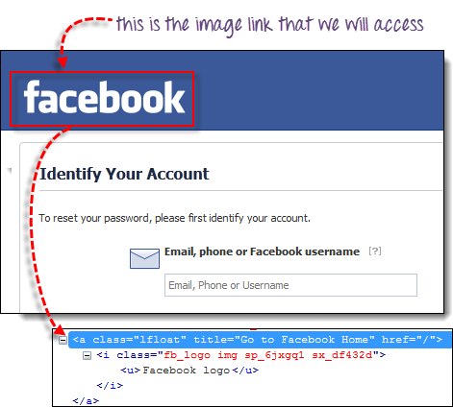

We will use By.cssSelector and the element’s “title” attribute to access the image link. And then we will verify if we are taken to Facebook’s homepage.
Program:
package practice_webdriver;
import org.openqa.selenium.*;
import org.openqa.selenium.firefox.FirefoxDriver;
public class ImageLink {
public static void main(String[] args) {

String baseUrl = "https://www.facebook.com/login/identify?ctx=recover";

WebDriver driver = new FirefoxDriver();

driver.get(baseUrl);

//click on the "Facebook" logo on the upper left portion

driver.findElement(By.cssSelector("a[title=\"Go to Facebook Home\"]")).click();

//verify that we are now back on Facebook's homepage

if (driver.getTitle().equals("Welcome to Facebook - Log In, Sign Up or Learn More")) {

System.out.println("We are back at Facebook's homepage");
} else {

System.out.println("We are NOT in Facebook's homepage");

}

driver.quit();

}

}

Xpath
There are times when we need to access elements (usually texts) that are within HTML tables. However, it is very seldom for a web designer to provide an id or name attribute to a certain cell in the table. Therefore, we cannot use the usual methods such as “By.id()”, “By.name()”, or “By.cssSelector()”. In this case, the most reliable option is to access them using the “By.xpath()” method.

XPath Syntax
Consider the HTML code below.
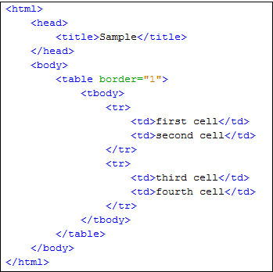
We will use XPath to get the inner text of the cell containing the text “fourth cell”.
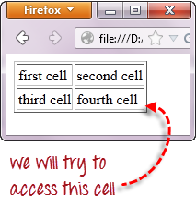
Step 1 – Set the Parent Element (table)
XPath locators in WebDriver always start with a double forward slash “//” and then followed by the parent element. Since we are dealing with tables, the parent element should always be the <table> tag. The first portion of our XPath locator should therefore start with “//table”.
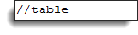
Step 2 – Add the child elements
The element immediately under <table> is <tbody> so we can say that <tbody> is the “child” of <table>. And also, <table> is the “parent” of <tbody>. All child elements in XPath are placed to the right of their parent element, separated with one forward slash “/” like the code shown below.
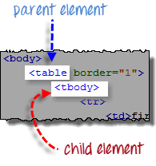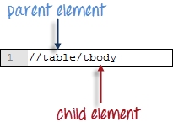
Step 3 – Add Predicates
The <tbody> element contains two <tr> tags. We can now say that these two <tr> tags are “children” of <tbody>. Consequently, we can say that <tbody> is the parent of both the <tr> elements.
Another thing we can conclude is that the two <tr> elements are siblings. Siblings refer to child elements having the same parent.
To get to the <td> we wish to access (the one with the text “fourth cell”), we must first access the second <tr> and not the first. If we simply write “//table/tbody/tr”, then we will be accessing the first <tr> tag.
So, how do we access the second <tr> then? The answer to this is to use Predicates.
Predicates are numbers or HTML attributes enclosed in a pair of square brackets “[ ]” that distinguish a child element from its siblings. Since the <tr> we need to access is the second one, we shall use “[2]” as the predicate.
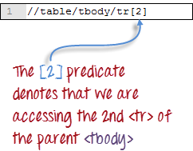
If we won’t use any predicate, XPath will access the first sibling. Therefore, we can access the first <tr> using either of these XPath codes.
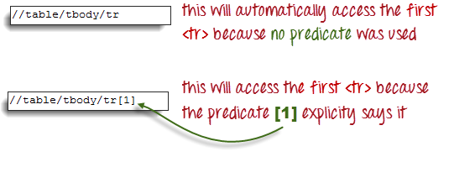
Step 4 – Add the Succeeding Child Elements Using the Appropriate Predicates
The next element we need to access is the second <td>. Applying the principles we have learned from steps 2 and 3, we will finalize our XPath code to be like the one shown below.
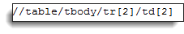
Now that we have the correct XPath locator, we can already access the cell that we wanted to and obtain its inner text using the code below. It assumes that you have saved the HTML code above as “newhtml.html” within your C Drive.
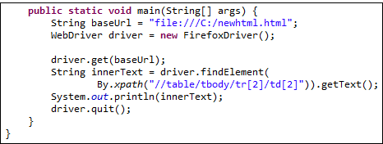
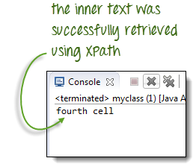

Accessing Nested Tables
The same principles discussed above applies to nested tables. Nested tables are tables located within another table. An example is shown below.
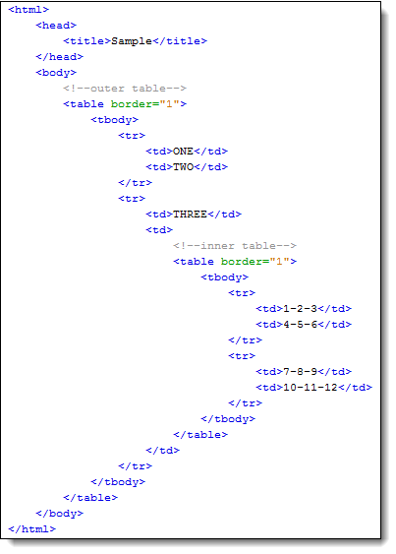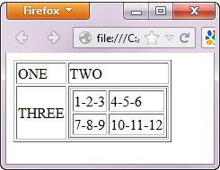
To access the cell with the text “4-5-6” using the “//parent/child” and predicate concepts from the previous section, we should be able to come up with the XPath code below.
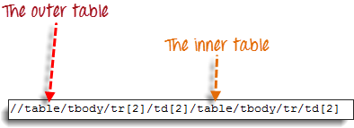

The WebDriver code below should be able to retrieve the inner text of the cell which we are accessing.
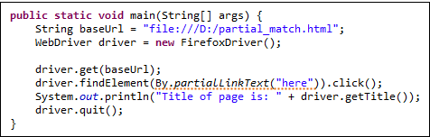
The output below confirms that the inner table was successfully accessed.
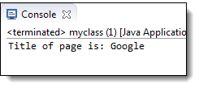
Read more at http://www.guru99.com/accessing-links-tables-selenium-webdriver.html#1exqCqKXtSur7L2p.99

Finding xpath through FireBug
If the number or attribute of an element is extremely difficult or impossible to obtain, the quickest way to generate the XPath code is thru Firebug.
Consider the example below from Mercury Tours homepage.
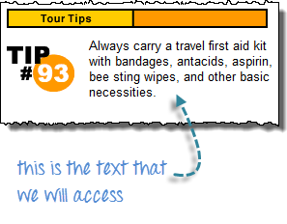
Step 1
Use Firebug to obtain the XPath code.
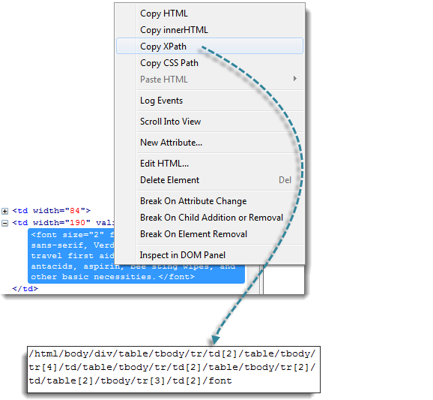

Step 2
Look for the first “table” parent element and delete everything to the left of it.
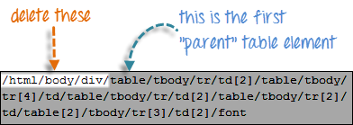
Step 3
Prefix the remaining portion of the code with double forward slash “//” and copy it over to your WebDriver code.
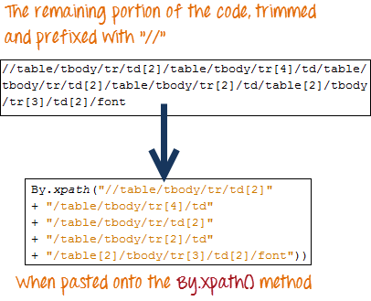
The WebDriver code below will be able to successfully retrieve the inner text of the element we are accessing.
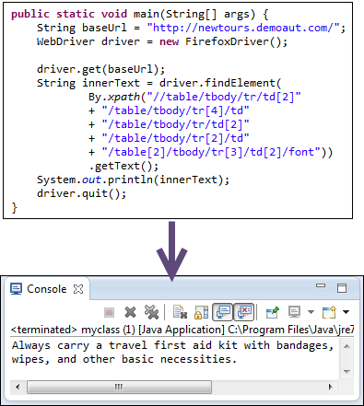

PageFactory
The PageFactory relies on using sensible defaults: the name of the field in the Java class is assumed to be the "id" or "name" of the element on the HTML page. That is, in the example above, the line:
q.sendKeys(text);
is equivalent to:
driver.findElement(By.id("q")).sendKeys(text);

Handling Cookies
With WebDriver user can add or delete the cookies

addCookie(Cookie cookie) - Add a specific cookie.

getCookies() - Get all the cookies for the current domain

deleteCookieNamed(String name) - Delete the named cookie from the current domain

deleteCookie(Cookie cookie) - Delete a cookie from the browser's "cookie jar".

deleteAllCookies() - Delete all the cookies for the current domain.
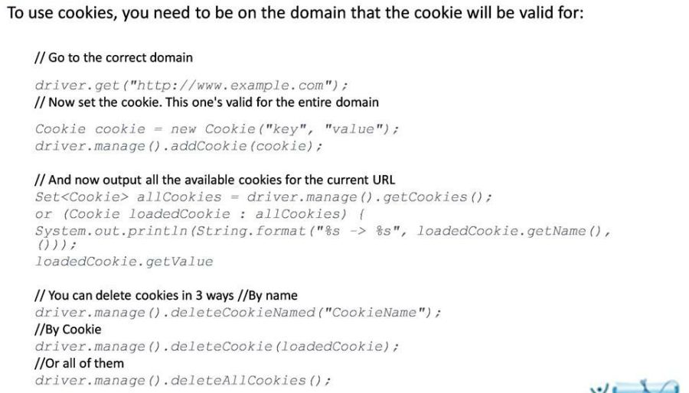

Setting Browser options [DesiredCapabilities]
The code snippet below is to specify the custom browser location for FireFox ,Chrome and also summarizes about disabling the protective mode for Internet Explorer browser.
DesiredCapabilities object can be used to set proxy details, specify binary location, setting custom profile etc.
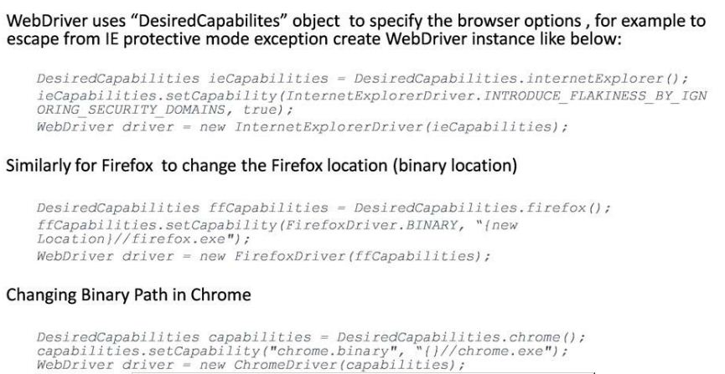

Specifying Browser proxy
If you want your tests to run with a browser proxy use the “DesiredCapabilities” object to specify the proxy.The proxy can also be specified as part of the browser profile for FireFox and Chrome.
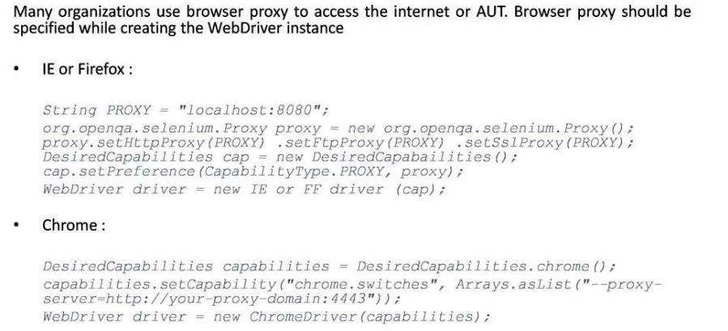

Important scripts & informations

TO find number of Frames in a web link
package PreLogin.AlltypesofLoginPage;

import java.util.List;
import java.util.concurrent.TimeUnit;

import org.openqa.selenium.*;

import org.openqa.selenium.firefox.FirefoxDriver;

import org.openqa.selenium.support.ui.ExpectedConditions;

import org.openqa.selenium.support.ui.WebDriverWait;

public class TofindNumberofFramesused {

public static void main(String[] args) {

String baseurl = "http://selenium.googlecode.com/svn/trunk/docs/api/java/index.html?overview-summary.html";
WebDriver driver = new FirefoxDriver();
driver.get(baseurl);
List<WebElement> ele = driver.findElements(By.tagName("frame"));
System.out.println("Number of frames in a page :" + ele.size());
String[] Framename = new String[ele.size()];

int i = 0;

//extract the link texts of each link element

for (WebElement e : ele) {

Framename[i] = e.getText();
System.out.println(e.getAttribute("name")); // we can get “id” , “ name” etc.. of the frames by mentioning it here
i++;
}
System.out.println("End of Execution");
driver.quit();
}
}

Important infos
Command | Value, Target, Wait Command
Selenium Control
setTimeout | milliseconds
setMouseSpeed | number of pixels
 | setMouseSpeedAndWait
setSpeed | milliseconds
 | setSpeedAndWait
addLocationStrategy | strategyName
 | addLocationStrategyAndWait
allowNativeXpath | boolean
 | allowNativeXpathAndWait
ignoreAttributesWithoutValue | boolean
 | ignoreAttributesWithoutValueAndWait
assignId | locator
 | assignIdAndWait
captureEntirePageScreenShot | filename, kwargs
 | captureEntirePageScreenShotAndWait
echo | message
pause | milliseconds
runScript | javascript
 | runScriptAndWait
waitForCondition | javascript
waitForPageToLoad | milliseconds
waitForPopUp | windowID
fireEvent | locator
 | fireEventAndWait
Browser Operations
open | url
 | openAndWait
openWindow | url
 | openWindowAndWait
goBack | goBackAndWait
refresh | refreshAndWait
close
deleteCookie | name
 | deleteCookieAndWait
deleteAllVisibleCookies | deleteAllVisibleCookiesAndWait
setBrowserLogLevel | logLevel
 | setBrowserLogLevelAndWait
Cookie Operations
createCookie | nameValuePair
 | createCookieAndWait
deleteCookie | name
 | deleteCookieAndWait
deleteAllVisibleCookies | deleteAllVisibleCookiesAndWait
Popup Box Operations
answerOnNextPrompt | answer
 | answerOnNextPromptAndWait
chooseCancelOnNextConfirmation | chooseCancelOnNextConfirmationAndWait
chooseOkOnNextConfirmation | chooseOkOnNextConfirmationAndWait
Checkbox & Radio Buttons
check | locator
 | checkAndWait
uncheck | locator
 | uncheckAndWait
Lists & Dropdowns
addSelection | locator
 | addSelectionAndWait
removeSelection | removeSelectionAndWait
removeAllSelections | removeAllSelectionsAndWait
Edit Fields
type | locator
 | typeAndWait
typeKeys | locator
 | typeKeysAndWait
setCursorPosition | locator
 | setCursorPositionAndWait
Keyboard Operations
keyDown | locator
 | keyDownAndWait
keyPress | locator
 | keyPressAndWait
keyUp | locator
 | keyUpAndWait
altKeyDown | altKeyDownAndWait
altKeyUp | altKeyUpAndWait
controlKeyDown | controlKeyDownAndWait
controlKeyUp | controlKeyUpAndWait
metaKeyDown | metaKeyDownAndWait
metaKeyUp | metaKeyUpAndWait
shiftKeyDown | shiftKeyDownAndWait
shiftKeyUp | shiftKeyUpAndWait
Mouse Operations
click | locator
 | clickAndWait
clickAt | locator
 | clickAtAndWait
doubleClick | locator
 | doubleClickAndWait
doubleClickAt | locator
 | doubleClickAtAndWait
contextMenu | locator
 | contextMenuAndWait
contextMenuAt | locator
 | contextMenuAtAndWait
mouseDown | locator
 | mouseDownAndWait
mouseDownA | locator
 | mouseDownAtAndWait
mouseMove | locator
 | mouseMoveAndWait
mouseMoveAt | locator
 | mouseMoveAtAndWait
mouseOut | locator
 | mouseOutAndWait
mouseOver | locator
 | mouseOverAndWait
mouseUp | locator
 | mouseUpAndWait
mouseUpAt | locator
 | mouseUpAtAndWait
dragAndDrop | locator
 | dragAndDropAndWait
dragAndDropToObject | sourceLocator
 | dragAndDropToObjectAndWait
Form Operations
submit | formLocator
 | submitAndWait
Windows/Element Selection
select | locator
 | selectAndWait
selectFrame | locator
selectWindow | windowID
focus | locator
 | focusAndWait
highlight | locator
 | highlightAndWait
windowFocus | windowFocusAndWait
windowMaximize | windowMaximizeAndWait

SELENESE TABLE FORMAT
Selenium commands identify elements within a Web page using:
identifier=id | Select the element with the specified @id attribute. If no match is found, select the first element whose @name attribute is id.
name=name | Select the first element with the specified @name attribute. The name may optionally be followed by one or more elementfilters, separated from the name by whitespace. If the filterType is not specified, value is assumed. For example, name=style value=carol
dom=javascriptExpression | Find an element using JavaScript traversal of the HTML Document Object Model. DOM locators must begin with "document." For example: dom=document.forms['form1'].myList dom=document.images[1]
xpath=xpathExpression | Locate an element using an XPath expression. Here are a few examples:  xpath=//img[@alt='The image alt text']  xpath=//table[@id='table1']//tr[4]/td[2]  /html/body/table/tr/td/a  //div[@id='manage_messages_iterator']  //tr[@class='SelectedRow']/td[2]  //td[child::text()='myemail@me.com']  //td[contains(child::text(),'@')]
link=textPattern | Select the link (anchor) element which contains text matching the specified pattern.
css=cssSelectorSyntax | Select the element using css selectors. For example:  css=ahref="/sites/all/modules/dzone/assets/refcardz/067/#id1"]  css=span#firstChild + span  Selenium 1.0 css selector locator supports all css1, css2 and css3 selectors except namespace in css3, some pseudo classes(:nthof-type, :nth-last-of-type, :first-of-type, :last-of-type, :only-of-type, :visited, :hover, :active, :focus, :indeterminate) and pseudo elements(::first-line, ::first-letter, ::selection, ::before, ::after). Without an explicit locator prefix, Selenium uses the following default strategies:  dom, for locators starting with "document." xpath, for locators starting with "//" identifier, otherwise
Your choice of element locator type has an impact on the test playback performance. The following table compares performance of Selenium element locators using Firefox 3 and Internet Explorer 7.
Locator used | Type | Firefox 3 | Internet Explorer 7
q | Locator | 47 ms | 798 ms
//input[@name='q'] | XPath | 32 ms | 563 ms
//html[1]/body[1]//form[1]//input[2] | XPath | 47 ms | 859 ms
//input[2] | XPath | 31 ms | 564 ms
document.forms[0].elements[1] | DOM Index | 31 ms | 125 ms
Additional details on Selenium performance can be found at:http://www.pushtotest.com/docs/thecohenblog/symposium

Mouse over Functions
See the example below.
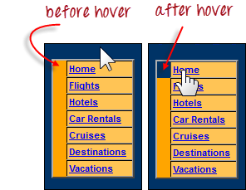
The cell shown above is a portion of a <TR> element. If not hovered, its color is #FFC455 (orange). After hovering, the cell’s color becomes transparent. It becomes the same color as the blue background of the whole orange table.
Step 1
Import the Actions and Action classes.
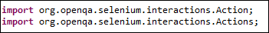
Step 2
Instantiate a new Actions object.
Step 3
Instantiate an Action using the Actions object in step 2.
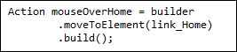
In this case, we are going to use the moveToElement() method because we are simply going to mouse-over the “Home” link. The build() method is always the final method used so that all the listed actions will be compiled into a single step.
Step 4
Use the perform() method when executing the Action object we designed in Step 3.
Below is the whole WebDriver code to check the background color of the <TR> element before and after the mouse-over

package mypackage;

import org.openqa.selenium.*;

import org.openqa.selenium.firefox.FirefoxDriver;

import org.openqa.selenium.interactions.Action;

import org.openqa.selenium.interactions.Actions;

public class myclass {

public static void main(String[] args) {

String baseUrl = "http://newtours.demoaut.com/";

WebDriver driver = new FirefoxDriver();

driver.get(baseUrl);

WebElement link_Home = driver.findElement(By.linkText("Home"));

WebElement td_Home = driver

.findElement(By

.xpath("//html/body/div"

+ "/table/tbody/tr/td"

+ "/table/tbody/tr/td"

+ "/table/tbody/tr/td"

+ "/table/tbody/tr"));

Actions builder = new Actions(driver);

Action mouseOverHome = builder

.moveToElement(link_Home)

.build();

String bgColor = td_Home.getCssValue("background-color");

System.out.println("Before hover: " + bgColor);

mouseOverHome.perform();

bgColor = td_Home.getCssValue("background-color");

System.out.println("After hover: " + bgColor);

driver.quit();

}

}

Important coding informations

For loop type
For that,
for (int i=0;i<myString.length;i++) {
System.out.println(myString[i]);
}
is correct.
For Java 5 an alternative was proposed. Any thing that implements iterable can be supported. This is particularly nice in Collections. For example you can iterate the list like this
List<String> list =....load up with stuff

for (String string : list) {
System.out.println(string);
}
instead of
for (int i=0; i<list.size();i++) {
System.out.println(string.get(i));
}

TestNG
TestNG has many features, which includes flexible test configuration, data-driven testing, parameterized testing, distributed test execution on slave machines.
It has feature rich execution reporting.
http://www.tutorialspoint.com/testng/testng_suite_test.htm

Annotation
An annotation describes the program, but is not part of the program code itself.
It is an instruction to compiler/runtime about the program.
Most frequently used TestNg annotations.
@Test,
@BeforeSuite,
@AfterSuite,
@BeforeTest,
@AfterTest,
@BeforeGroups,
@AfterGroups,
@BeforeClass,
@AfterClass,
@BeforeMethod,
@AfterMethod,
@DataProvider,
@Parameters

@TestAnnotation-Attributes
Attribute ‘description’ tells, the description for this method, it is useful in reports.
Attribute ‘enabled’ tells, whether the test method is enabled for execution. if disabled, the method will not be executed
Attribute ‘groups’ tells, the list of groups this method belongs to.Test methods can be grouped together and executed using its group name.
Attribute dependsOnMethods tells, the list of methods this method depends on. This method will be executed once the dependent method is passed, otherwise it will be skipped.
Attribute ‘dependsOnGroups’ tells, the list of groups this method depends on. This method will be executed once the last test method in dependent group is passed, otherwise it will be skipped
Attribute ‘dataProvider’ tells, the test uses the data provider specified. DataProvider is a method which is annotated as @DataProvider, which supplies test data to test method
Attribute ‘alwaysRun’, If set to true, this test method will always be run, even if it depends on a method/group that is failed.
Attribute ‘expectedExceptions’ tells, the list of exceptions that a test method is expected to throw. If the test method throws an expected exception, the test case will pass. If the test method throws an exception which not in expected list, the test case will fail. Lets see more details in chapter 8.
Attribute ‘timeOut’ tells, the maximum number of milliseconds current test thread should take. If a test case runs beyond the mentioned time, TestNG terminates that test case execution.

TestNG-Grouping
Test methods can be grouped by defining group names with @Test annotation, on each test method
A test method can belong to multiple groups and test groups can be included/excluded from test suite

Data Provider
The annotation @DataProvider marks a method as data provider for a test method.
The annotated method must return array of array, where each array represents array of arguments to test method.
As shown in the example,the test method ‘test’ takes an integer and a string argument.
So The data provider should return, an array of array. Where each array contains an integer and a string value.
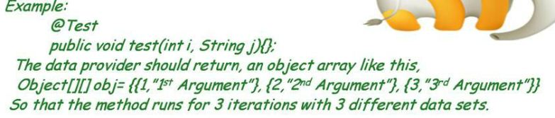
The test method that wants to receive data from this Data Provider needs to use a data Provider name equals to the name of this annotation

ExpectedExceptions
The attribute @expectedExceptions defines the list of exceptions that a test method is expected to throw.
If an exception mentioned in the list is thrown, the test method will be marked as passed by TestNG.
If no exception or a different than one on this list is thrown, the test will be marked a failure by TestNG.

Test Suite
By creating a test suite in xml format, organizing and execution of large number of tests becomes more flexible and easier.
Go through the xml.
<!DOCTYPE suite SYSTEM "http://testng.org/testng-1.0.dtd" >
<suite name="Suite1" verbose="10" parallel = "methods">
<test name="Regression1">
<classes>
<class name="test.sample.SampletestClass" />
</classes>
</test>
<test name="Regression2">
<classes>
<class name="test.sample.sampletestClass1"/>
<class name="test.sample.sampletestClass2"/>
</classes>
<packages>
<package name="test.sample"/>
</packages>
</test>
</suite>

The opening and closing ‘suite’ tag, consists one or more tests

The opening and closing ‘test’ tag, consists one or more packages or classes. If a package is specified, all classes conaining test methods in that package will be added to execution.User can define attributes like preserve-order="true”. These attributes will be applicable to all of the test methods and can be overridden by child level tag attributes

The opening and closing ‘Classes’ consists one or more classes containing test methods.

In this example below , you can pasIn this example, you can pass the suite parameters, where the testNG passes them as arguments to the methods on which the parameters are defined in test classes.

Groups tag can be used to include or exclude test groups to the test.

Methods tag can be used to include or exclude only the specified test methodss the suite parameters, where the testNG passes them as arguments to the methods on which the parameters are defined in test classes
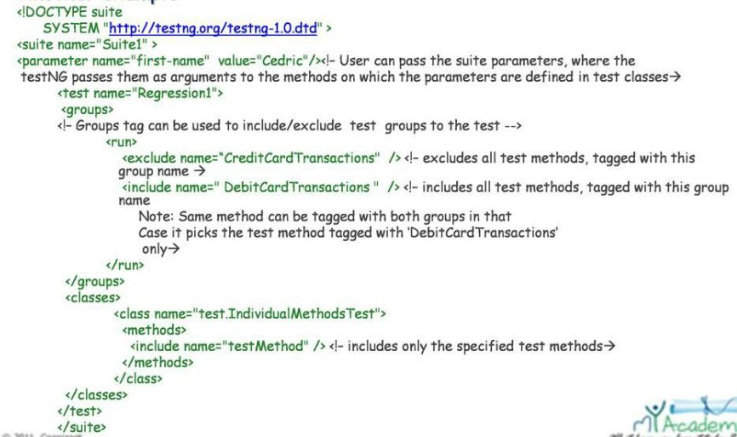

Run Test Suite
Now how to run the Test Suite

Download testng--jdk.jar
Add this jar to classpath.
Compile your java file and copy the class file to classpath.
Run this command in your command line “java org.testng.TestNG <projectPath>\testng.xml” You can create an ant target and invoke the tests from build.xml.

TestNG Report
TestNG generates different types of html and xml reports.
TestNG reports are saved to test-output folder directory with suite name as folder name
TestNG events (start,pass,fail,skip,exit) are listened by default listener provided by TestNG, and can be overridden by customized listeners.
To create customized listeners, one should implement listener interfaces provided by TestNG “ITestListener”, and override the default listeners by custom listeners.
TestNG generates reports like index.html(main report), classes.html(class wise display), groups.html(group wise display), emailable-report(cumulative and most commonly used) etc

Difference between Junit & TestNG
Dependency features
JUnit framework doesn’t have test dependency features but TestNG framework comes with dependent testing features.
Dependencies between tests can be created, which ensures the order of test execution.
TestNG skips the tests, if the dependent tests are failed.
Advanced Parametric Testing
Junit doesn’t support data providers, TestNG comes with data provider feature,
Grouping
Junit doesn’t support grouping, TestNG comes with grouping features
Reposrting features
Junit doesn’t come with html reporting features, TestNG comes with very good reporting features,

Parametric Testing
In JUnit, if you want to vary the data parameter groups to a method under test, you are forced to write a test case for each unique group.
TestNG framework comes parametric testing features. If you want to vary the data parameter groups to a method under test, you can pass the parameters from suite, so that same test method can be used to test other parameter group by changing parameters in suite.
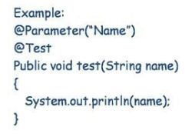

TestNG Summary
The summary of all chapters,

TestNG is an open source framework to develop datadriven 'Unit/functional tests for JAVA APIs' and 'UI tests using java based tools'.

TestNG can be installed as a plugin and most of the tools like eclipse, netbeans, ant, maven, hudson support it.

The methods are identified by the annotations defined on them by TestNG.
Test methods can be grouped together and the groups can be included excluded in test suite.
The Data Provider is test data supplier to tests, which enables users to develop data driven tests.
Tests can be combined together in test suite, and executed.
Test methods, Test groups can be included, excluded from test suite.
Tests with expected exceptions are passed, when the exception from the expected exceptions group is thrown.
TestNG comes with good reporting features and by overriding default listeners, one can create customized reports

Change Log
Version Number | Changes made
V1.1 | Implemented the core functionality
V1.2
V1.2 | Page no | Changed by | Effective date | Changes effected
V1.2 |  | Vijayakarthikeyan | 27/12/2012

